

2026 - 2029

DISABILITY ACCESS & INCLUSION PLAN




Prepared under the Disability Inclusion Act 2018 (SA). Aligned with the State Disability Inclusion Plan 2025-2029.


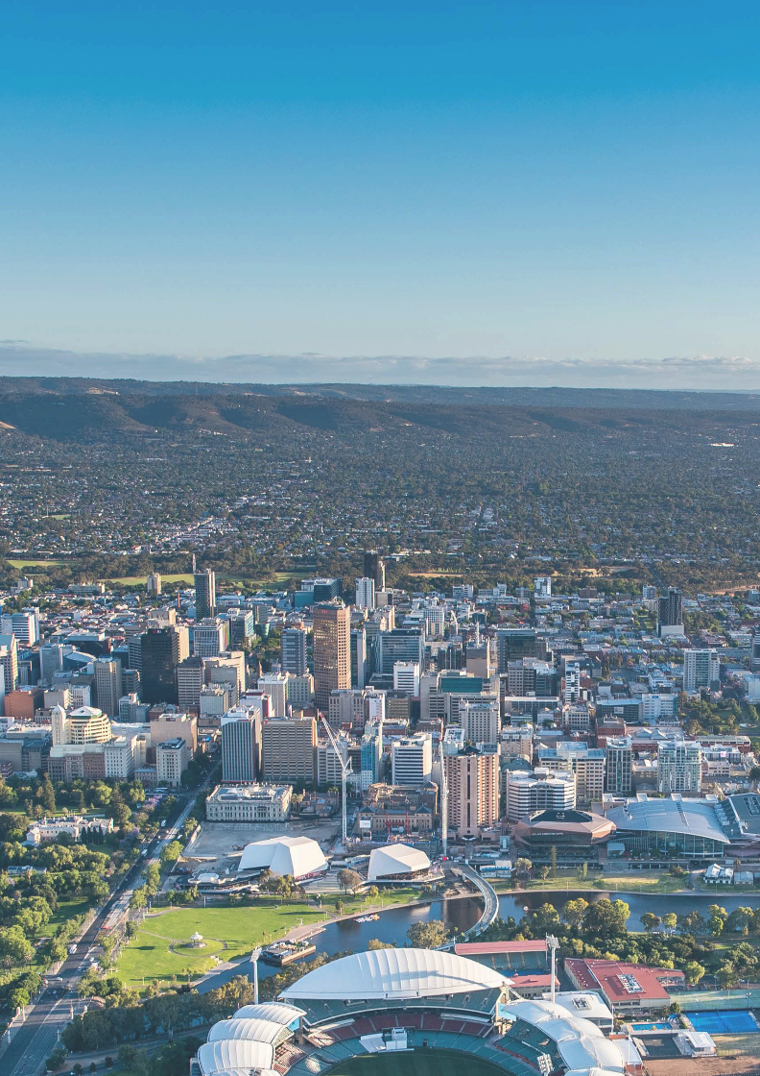

ACKNOWLEDGEMENT OF COUNTRY
Adelaide Venue Management acknowledges the Kaurna people as the Traditional Custodians of the Adelaide Plains, on whose lands our venues operate. We pay our respects to Elders past, present, and emerging, and extend that respect to all to all Aboriginal and Torres Strait Islander peoples who visit and work at our venues.
We acknowledge that Aboriginal and Torres Strait Islander people with disability may experience intersecting forms of discrimination, and we are committed to ensuring their voices, needs and aspirations are reflected in the design, development and delivery of this Plan.

Produced by First Nations artist, Ben Williams, the above artwork reflects the position of AVM’s three venues on the banks of the Karrawirra Pari / River Torrens and our commitment to work together as one community.

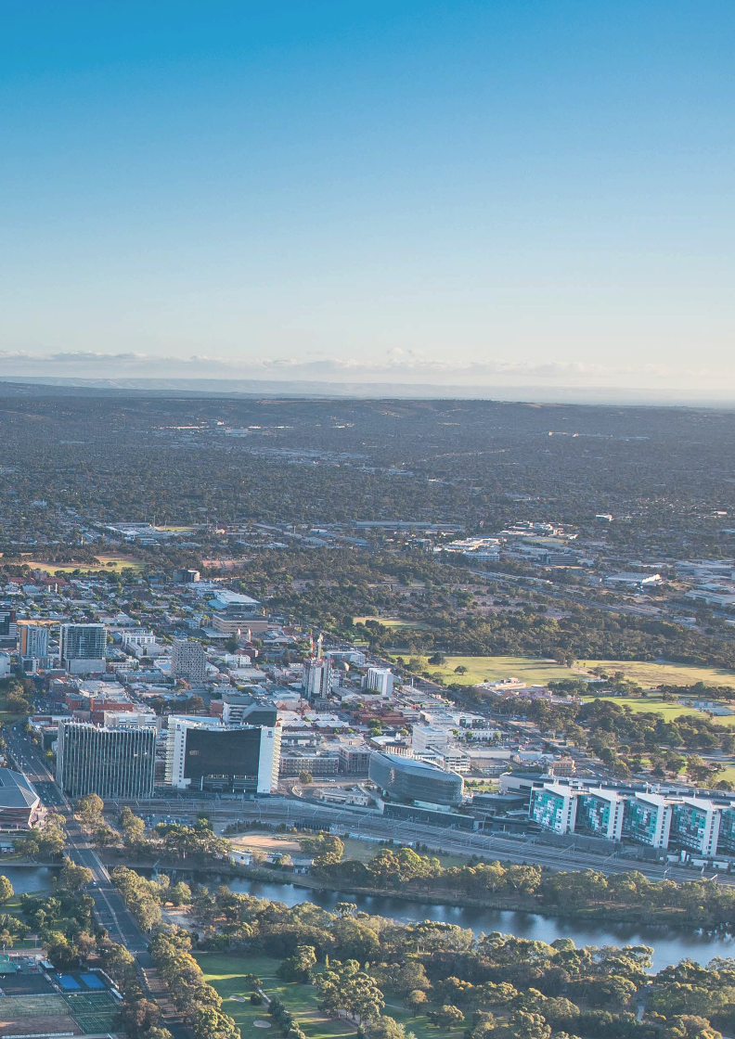

Table of contents
- Message from the CEO 05
- About Adelaide Venue Management 07
- Our Vision, Team and Workplace 08
- Strategic Context 09
- Priority Groups 10
- Disability Access and Inclusion Plan Development 12
- Objective 1: Accessible built environments and infrastructure 14
- Objective 2: Accessible information, wayfinding, parking and 17
transport
- Objective 3: Team member capability, culture and inclusion 20
- Objective 4: Accessible events, services and digital experiences 23
- Objective 5: Inclusive employment and workplace adjustments 26
- Objective 6: Feedback complaints and continuous improvement 29
- Objective 7: Consultation, partnerships and community impact 32
- Implementation 35
- Acknowledgements 36
- Glossary 37

Message from the CEO


I am pleased to introduce Adelaide Venue Management’s Disability Access and Inclusion Plan 2026–2029.
Each year, more than one million people come through the doors of Adelaide Convention Centre, Adelaide Entertainment Centre and Coopers Stadium - to celebrate, learn, compete, perform and connect. The role of Adelaide Venue Management (AVM) is to ensure the venue experiences it offers are open, welcoming and accessible to all.
This is AVM’s third Disability Access and Inclusion Plan (DAIP), building directly on the strong foundations of the 2017–2020 and 2022–2025 plans. Inclusion is part of who we are and how we operate. In recent years, AVM has continued to raise the standard of inclusive venues in South Australia - from embedding the Hidden Disability Sunflower program into our everyday service, to redesigning spaces with input from practitioners with lived experience.
Improvements include expanded accessible parking, upgraded seating and sightlines, the introduction of all-gender facilities, and creation of sensory and quiet spaces.
Hundreds of AVM team members have also completed Autism Awareness and Hidden Disability training, while our DDA Working Groups - guided by the advice of lived-experience advisors - have played a key role in shaping this Plan.
This Plan now places that progress on a renewed footing. As a state authority under the Disability Inclusion Act 2018 (SA), AVM must ensure its venues, services and workplace are accessible and inclusive. This Plan directly aligns with the State Disability Inclusion Plan 2025–2029, and supports Australia’s Disability Strategy 2021–2031 and the United Nations Convention on the Rights of Persons with Disabilities. Across seven AVM objectives - mapped to the State Plan’s five domains
- it sets measurable actions, clear timeframes and defined responsibilities, including targeted commitments for the seven priority groups identified in the State Plan.
On behalf of AVM, I fully endorse this Plan. AVM will report against this Plan annually to the Chief Executive of the Department of Human Services, in line with section 17 of the Disability Inclusion Act, and publish our progress on the AVM website.
This is a living document. The AVM Management team will review and update it as community needs evolve, with transparency about what is working and where to improve.
To everyone with lived experience of disability who has contributed to this Plan, thank you. To everyone who will hold us to it, we welcome that. A venue is more than a building - it is a promise that you belong here. This Plan is part of how we will continue to deliver on that promise.
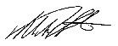

Martin Radcliffe
Chief Executive Officer

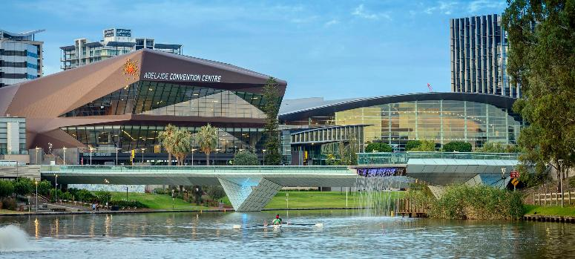
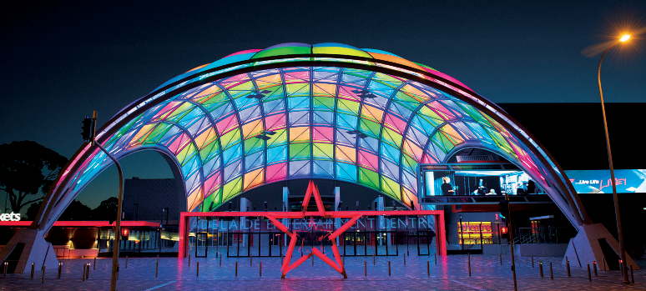
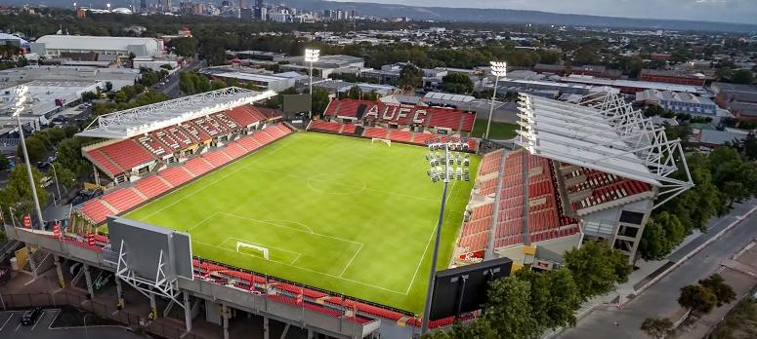

About Adelaide Venue Management

Adelaide Venue Management (AVM) is a South Australian Government statutory corporation responsible for the operation of Adelaide Convention Centre, Adelaide Entertainment Centre and Coopers Stadium. As a state authority within the meaning of the Disability Inclusion Act 2018 (SA), AVM is required to develop, publish and report against a Disability Access and Inclusion Plan (DAIP).
Each year, AVM welcomes more than one million visitors across a diverse range of business events, concerts, performances, sporting fixtures, exhibitions and community gatherings. As the operator of major public venues, AVM recognises its responsibility to ensure that its facilities, services, communications, employment practices and supply chains are accessible to, and inclusive of, all people.
This Disability Access and Inclusion Plan applies across all AVM venues, to all AVM team members (including casual and contracted), and all events delivered by, or hosted at, AVM venues.

Our Venues
Adelaide Convention Centre (ACC) opened in 1987 and underwent significant expansions in 1991, 2001 and again between 2011–2017 via a $395 million redevelopment. The venue is purpose-built to contemporary accessibility standards.
Adelaide Entertainment Centre (AEC) opened in 1991 with the Arena and was expanded in 2010, with the addition of the Theatre and Orb Entry. Due to the age of the original Arena, some accessibility limitations remain, including patron access to the Arena floor for concerts and to Corporate Suite seating. These limitations were identified in the 2017–2020 and 2022–2025 Disability Access an Inclusion Plans, and remain priorities for advocacy, and where possible, modification under this Plan.
Coopers Stadium was most recently redeveloped in 2022 via a $53.5 million upgrade, delivering three additional lifts, accessible service counters at concession outlets, increased undercover accessible seating in the East Stand, and a new fully accessible East Stand corporate facility. AVM has managed the Stadium since 1 July 2013.

Our Vision, Team and Workplace

Our Vision
With regard to disability, access and inclusion, AVM’s vision is to create is to create a workplace and event environment where everyone - team members, clients and visitors - feel respected, represented, safe, and able to fully participate.
To achieve this, AVM commits to:
  - Removing barriers - physical, communicative, attitudinal, systemic, technological, social and cultural - to access and inclusion across its venues.
  - Embedding disability inclusion as core business, not an optional add-on.
  - Engaging people with lived experience of disability in the design and delivery of services.
  - Supporting the rights of people with disability under the United Nations Convention on the Rights of Persons with Disabilities and the Disability Inclusion Act 2018 (SA).

Our Team and Workplace
As at 26 June 2026, 1.17% of AVM team members identify as having a disability, based on voluntary self-identification recorded in AVM’s Human Resources Information System (HRIS).
AVM recognises that this figure reflects disclosure rather than prevalence. Self-identification is voluntary, and a range of factors - including concerns about privacy, stigma or the perceived consequences of disclosure, and the fact that many disabilities are non-visible - mean that recorded rates typically understate the true representation of people with disability
in any workforce. AVM’s actual representation is therefore likely to be higher than the recorded rate.
Improving the safety and confidence with which team members can choose to share this information, and increasing self-identification rates over the life of this Plan, is a measured commitment under Objective 5: Inclusive employment and workplace adjustments.
This focus on workforce representation and inclusion is embedded across AVM’s strategic framework. The AVM Strategic Plan 2024–2027 sets the organisation’s overarching direction; the AVM DEI Strategy 2026–2029 outlines AVM’s diversity, equity and inclusion commitments, including disability representation;
and the AVM ESG Strategy (The Green Print) incorporates these priorities as part of AVM’s broader social sustainability commitments.
AVM’s commitment to people with disability also extends beyond its own workforce to the
community it serves. Through its Community Impact Program, AVM partners with local South Australian organisations across key pillars of ‘Community’, ‘Environment’, ‘First Nations’ and ‘Goods Donation’
- reflecting the same principles that underpins this Plan: that AVM’s venues, workforce and partnerships should leave a lasting, inclusive legacy in South Australia.
AVM has set workforce representation targets for people with disability at a minimum 3% baseline and with a stretch target of 5–6% by 2029. These targets, along with broader workforce diversity commitments, are detailed in the actions table under Objective 5.

Strategic Context

This DAIP operates within a layered framework of international, national and state instruments that recognise and protect the rights of people with disability.

International
  - United Nations Convention on the Rights of Persons with Disabilities (UNCRPD)

National
  - Australia’s Disability Strategy 2021–2031 (ADS) - replaces the National Disability Strategy 2010–2020 referenced in AVM’s prior DAIPs
  - Disability Discrimination Act 1992 (Cth)
  - Disability (Access to Premises - Buildings) Standards 2010
  - National Autism Strategy 2025–2031

State
  - Disability Inclusion Act 2018 (SA) and Disability Inclusion Regulations 2019 - replaces the Disability Services Act 1993 (SA) referenced in AVM’s prior DAIPs
  - Disability Inclusion (Review Recommendations) Amendment Act 2024
  - State Disability Inclusion Plan 2025–2029
  - SA Autism Strategy 2024–2029
  - Equal Opportunity Act 1984 (SA)
  - Carers Recognition Act 2005 (SA)

This DAIP aligns its objectives and actions with the State Disability Inclusion Plan 2025–2029.
While the structure of this Plan continues AVM’s established six-objectives format (with a seventh objective added for 2026–2029), each action is mapped to the State Plan’s domains and measures.

Priority Groups

The State Disability Inclusion Plan 2025–2029 and the Disability Inclusion Act 2018 (SA) recognise that some people with disability experience intersecting forms of discrimination and may face additional barriers to accessing mainstream supports and services. AVM commits to addressing the rights and needs of the seven priority groups identified in the State Plan through the actions in this DAIP.

AVM also recognises that individuals may identify with more than one priority group, and that an intersectional approach is essential. The following commitments apply across all seven AVM objectives:

Culturally and linguistically diverse (CALD) people with disability
  - Multilingual event accessibility information provided for major events with diverse audiences.
  - Cultural awareness embedded in mandatory team member training, including how culture intersects with disability.
  - Engagement with CALD disability advocacy organisations during DAIP review and major venue projects to inform inclusive design and service delivery.

Aboriginal and Torres Strait Islander people with disability
  - Cultural safety protocols, developed with Kaurna Elders and Aboriginal disability advocates, embedded in event planning and customer service training.
  - Aboriginal employment pathways at AVM, with disability inclusion considerations integrated into recruitment and onboarding.
  - Consideration of Aboriginal-led businesses in procurement, where possible, including
Aboriginal-led disability service providers where appropriate.

Women with disability
  - Workforce data disaggregated by gender and disability to identify and address gaps in pay, progression and representation.
  - Safety-by-design measures across AVM venues, including well-lit accessible pathways, visible security presence, and clear reporting pathways for harassment, recognising that women with disability face elevated risks.

Children and young people with disability
  - Sensory-friendly sessions at AVM venues, alongside support for relaxed performances where promoters and event hirers choose to offer them, designed with input from families and disability advocates.
  - Accessible school program tours prioritised for schools serving students with disability.
  - Family rooms and quiet spaces provided at major family-oriented events.

- LGBTIQA+ people with disability
  - All-gender toilet facilities maintained across AVM venues.
  - LGBTIQA+ inclusion content included in mandatory DEI training, with specific attention to the intersection with disability.
  - Inclusive language used across all customer-facing communications, with non-binary options on forms and registrations.

People with intellectual disability or who are more at risk because of their disability
  - Easy Read versions of all key AVM accessibility information, including this DAIP, event accessibility guides and emergency procedures.
  - Customer-facing team members trained in plain-English communication, including allowing time for people to process information.
  - Hidden Disability Sunflower program maintained, recognising that many people with intellectual disability choose to use the Sunflower lanyard.
  - Long-standing partnership with Barkuma continued (see Objective 7), providing sustainable employment pathways for people with intellectual disability.

People with disability who live in regional communities
  - Pre-event accessibility information published well in advance, enabling regional visitors to plan travel, accommodation and support arrangements.
  - Accessible drop-off and pick-up arrangements coordinated with regional community transport providers where required.
  - Accessibility standards extended to partnerships, so that where AVM delivers events with regional communities, consistent inclusion practices are maintained.

Disability Access and Inclusion Plan Development

Continuity
This is AVM’s third Disability Access and Inclusion Plan, building directly on the work of:
  - AVM Disability Access and Inclusion Plan 2017–2020
  - AVM Disability Access and Inclusion Plan 2022–2025
Each chapter that follows opens with an honest assessment of progress against the corresponding actions in the 2022–2025 Plan, before outlining AVM’s current state and setting out actions for the 2026–2029 period. Where commitments from the prior Plan have been delivered, this is acknowledged; where they remain in progress or unresolved,
they are carried forward; and where the operating environment has changed, new actions have been introduced.

Consultation
In developing this DAIP, AVM undertook public consultation in accordance with Section 16(4) of the Disability Inclusion Act 2018 (SA). This section serves as AVM’s report under Regulation 9(4) of the Disability Inclusion Regulations 2019 (SA).
Consultation to inform this Plan commenced in June 2024 and drew on multiple channels designed to engage people with lived experience of disability, AVM team members, clients and venue patrons.
In November 2024, AVM commissioned an independent ‘lived experience’ access assessment of Adelaide Convention Centre and Adelaide Entertainment Centre, focused on identifying and evaluating access and inclusion across the venues. This assessment was completed by Mr Warwick
Gregg of Buildsurv. In July 2025, AVM also partnered with Autism SA to undertake an audit of the venues from the perspective of an autistic patron.

Insights from these assessments have directly informed the development of this DAIP. AVM’s measures and progress in this area were subsequently shared with the South Australian Minister for Human Services, who acknowledged and commended AVM’s progress and proactive approach.
In addition, AVM has established partners and programs, including the Disability Discrimination Act (DDA) Working Groups at Adelaide Convention Centre and Adelaide Entertainment Centre, participation in the Hidden Disability Sunflower program, and partnerships with Autism SA, the Office of Autism and Barkuma. AVM also gathers direct feedback from clients through a targeted client survey, and from patrons from an onsite QR code surveys designed to facilitate quick, accessible responses.
Several consistent themes emerged from consultation with AVM team members. These included a desire
to increase awareness of disability inclusion and of the services and amenities available across AVM venues; to review the terminology used in policies, procedures and communications so that it is consistently inclusive; and to expand education and training opportunities. In response to this feedback, AVM has established a Diversity, Equity and Inclusion (DEI) Committee to provide ongoing governance and oversight of disability inclusion. Themes identified through consultation have directly shaped the
actions set out in this Plan. This Committee includes representation from all key departments across AVM venues and corporate function, and includes members with lived experience of disability and First Nations representation.

Relationship to other policies, strategies and frameworks
This DAIP is the principal mechanism through which AVM gives effect to its obligations under the Disability Inclusion Act 2018 (SA). It is supported by, and operates alongside:
- AVM Strategic Plan 2024–2027, which sets AVM’s overarching strategic direction.
- AVM ESG Strategy (The Green Print), which embeds social sustainability commitments.
- AVM Workplace Adjustments Policy (CSP063), which operationalises the workplace adjustment commitments outlined in Objective 5.
- AVM DEI Committee Terms of Reference, which establish governance and oversight of this Plan.
- Adelaide Convention Centre Accessibility Guide, which provides an operational standard for accessible event delivery.
- AVM Reconciliation Action Plan, which guides engagement with Aboriginal and Torres Strait Islander communities, including people with disability.
- AVM Community Impact Program, which extends AVM’s social impact into the community through partnerships across community, environment, First Nations and goods donations, supporting inclusive event legacies in South Australia.

Objective 1:

Accessible built environments infrastructure

AVM commits to providing built environments across all three venues that are designed, maintained and continuously improved to enable people with disability to participate fully and safely. This objective covers physical access, Universal Design, accessible facilities, sensory and neurodiversity infrastructure, and where feasible, resolution of historical accessibility limitations.

Progress against the 2022-2025 Plan
The below status assessments summarise and evidence the achievements of the 2022-2025 Plan. All statuses are subject to verification by AVM People Department and the Executive Leadership Team before publication.

2022-2025 Action | Inferred Status | Comment / Carry-forward
1.1 Review DDA design requirements ahead of any building project (Ongoing) | Carried forward | AVM continues to apply current DDA and Premises Standards requirements at design stage. Now strengthened by Universal Design principles — see Action 1.1.1.
1.2 Maintain venue issue log to inform design of new venues (Ongoing) | Carried forward | Issue log maintained. Continues under the renewed accessibility audit programme — see Action 1.2.1.
1.3 Maintain Facility Guide / Exhibitor Services kit with accessibility guidance (Dec 2023; Dec 2025) | Delivered | Inferred from broader Inclusive Events Operational Framework implementation. Carried forward and strengthened — see Action 1.3.1.
1.4 Continue to review emergency evacuation procedures including special needs requirements (Annual) | Delivered (annual) | Carried forward and strengthened with PEEPs under Objective 4 (Action 4.5.1).
1.5 Continue to lobby governments for new arena or significant AEC upgrades (Ongoing) | Carried forward - unresolved | AEC Arena floor and Corporate Suite accessibility limitations identified in both prior Plans remain. Lobbying continues — see Action 1.5.1.

Current state and intent for 2026-2029
AVM’s three venues span more than 35 years of evolving accessibility standards. Adelaide Convention Centre (substantially completed in 2017) reflects current Premises Standards. Adelaide Entertainment Centre Arena (1991) and Coopers Stadium (1960 grandstand, redeveloped 2000 and 2022) contain heritage elements where the Disability Discrimination Act (DDA) standards is not feasible without significant redevelopment.
Significant progress has been made under the 2022–2025 Plan. At Adelaide Convention Centre, this includes increased accessible parking, high-contrast stair treads, sliding-glass access points, all-gender toilets, wheelchair-accessible foyer tables, and improved accessibility signage. At Adelaide Entertainment Centre, improvements include ramp upgrades, sightline-enhanced seating, elimination of double-stacked wheelchair seating, and upgrades to corporate suite accessibility. At Coopers Stadium, key enhancements include three additional lifts, accessible concession counters, and a fully accessible East Stand corporate facility.
For the 2026–2029 period, AVM will apply Universal Design principles to capital works wherever practicable, maintains regular accessibility audits at Adelaide Convention Centre and Adelaide Entertainment Centre, continue rollout of sensory-friendly and neurodiversity supports, and renew advocacy to address the long-standing accessibility limitations of Adelaide Entertainment Centre’s Arena floor and Corporate Suites.

Actions 2026-2029

No. | Action | State Plan Measure | AVM Measure | Timeframe | Responsibility & data source
1.1.1 | Seek to apply Universal Design principles to  all capital works and refurbishment projects at AVM venues, wherever practicable, with  lived-experience review  at design stage where possible. | 1.3 Universal Design measures (Domain 1) | % of capital works projects  ≥$250k assessed against Universal Design checklist where practicable (target 80%). | Ongoing from Year 1 | Facilities Management; Project files
1.2.1 | Maintain and, where practicable, publish a regular accessibility audit of the Adelaide Convention Centre and Adelaide Entertainment Centre against the  Premises Standards 2010, and against WCAG 2.2 AA principles for digital wayfinding where such tools are in place. | 1.3 Universal Design measures (Domain 1) | Audit completed; number of accessibility recommendations actioned vs. raised | Regular | Facilities Management; Audit reports

No. | Action | State Plan Measure | AVM Measure | Timeframe | Responsibility & data source
1.3.1 | Maintain the Inclusive Events Operational Framework — including the Accessibility Standard, Sensory & Neurodiversity Standard, Inclusive Communication Standard, Cultural Inclusion Standard, Frontline Staff Capability Standard, and Event Inclusion Assessment  Tool — and seek to make the accessibility guidance components available  to event hirers, where  practicable. | 3.1 Accessibility measures (Domain 3) | % of major event hirers receiving accessibility briefing pack where practicable  (target 90%). | Per event; annual rollup | Head of Sales, Convention & Exhibitions; Contracts register
1.4.1 | Maintain accessible and  all-gender toilet facilities at AVM venues, with signage compliant with AS 1428. | 1.4 Accessible facilities measures (Domain 1) | % of accessible toilets meeting AS 1428  compliance at annual audit (target 100%). | Annual audit | Facilities Management; Audit reports
1.4.2 | Investigate the addition of Changing Places facilities at AVM venues, in consultation with the Changing Places Australia network and lived-experience advocates. | 1.4 Accessible facilities measures (Domain 1) | Feasibility study completed  by Year 2; implementation plan by Year 3 if feasible. | Year 2–3 | Facilities Management; Feasibility report
1.5.1 | Continue to advocate to State Government for the resolution of unresolved accessibility  limitations at the Adelaide Entertainment Centre Arena — including Arena floor access for concerts and Corporate Suite access — through either significant upgrade or future redevelopment. (Carried forward from 2022–2025 Action 1.5). | 1.3 Universal Design measures (Domain 1) | Number of formal advocacy engagements per year; documented government responses. | Ongoing | General Manager AEC/CS;  Advocacy register

No. | Action | State Plan Measure | AVM Measure | Timeframe | Responsibility & data source
1.6.1 | Continue rollout of high-contrast wayfinding, tactile indicators, sensory rooms and neurodiversity  supports identified through the DDA Working Groups. | 1.3 Universal Design measures (Domain 1) | Number of universal- design upgrades delivered per year; spend on accessibility upgrades. | Annual | Facilities Management; Finance system

Objective 2:

Accessible information, wayfinding, parking & transport

AVM commits to providing accurate, accessible and timely information about its venues, events, parking, transport and emergency arrangements, in formats that meet the needs of people with disability. This objective covers digital communications, plain English, Easy Read, signage, wayfinding, accessible parking and engagement with public transport providers.

Progress against the 2022-2025 Plan
The below status assessments summarise and evidence the achievements of the 2022-2025 Plan. All statuses are subject to verification by AVM People Department and the Executive Leadership Team before publication.

2022-2025 Action | Inferred Status | Comment / Carry-forward
2.1 Review wayfinding strategies for mobility restricted and disabled persons (Biennial Dec 2023, 2025) | Delivered | Carried forward and broadened to all access needs, not only mobility — see Action 2.1.1.
2.2 Review and maintain Venue Site Maps showing step-free routes (Biennial) | Delivered | Maps maintained. Continues under Action 2.2.1, with digital-first delivery and WCAG  2.2 AA compliance.
2.3 Review and update external and internal venue signage (Biennial) | Delivered | Signage upgrades documented at all three venues. Continues under Action 2.1.1.
2.4 Consider opportunities for signage in alternate formats (braille and audio) (Biennial) | Partially delivered | Limited uptake to date. Re-prioritised under Action 2.3.1 with concrete commitment to Easy Read and alternative formats.
2.5 Review and update website public-transport information (Annual) | Delivered | Information maintained on AVM websites. Continues under Action 2.4.1, with formal engagement with the Department for Infrastructure and Transport added.

Current state and intent for 2026-2029
Information can itself presente an access barrier when it is not available in formats that people with disability can use, or at the times when they need it. AVM’s prior Plans treated information, wayfinding, parking and public transport together as a single objective, and this combination remains appropriate because each element relies on the others: a step-free route is only useful if visitors are aware it exists, and an accessible parking bay is only useful if the public-transport alternative is described clearly enough to demonstrate it isn’t required.
Under the 2022–2025 Plan, AVM made progress with accessible parking (18% increase at Adelaide Convention Centre, expanded and relocated bays at Adelaide Entertainment Centre), pre-event accessible parking booking, and maintenance of accessible web information. Gaps remain in the provision of alternative-format publications (Easy Read, braille, audio), and accessible parking proximity at Coopers Stadium remains constrained by site geography.
For the 2026–2029 period, AVM commits to WCAG 2.2 Level AA compliance for digital content wherever practicable, an Easy Read commitment for all key accessibility information including this DAIP, advance publication of event-specific accessibility information for all ticketed events, and strenghtening engagement with the Department for Infrastructure and Transport on accessible public-transport access to AVM venues.

Actions 2026-2029

No. | Action | State Plan Measure | AVM Measure | Timeframe | Responsibility & data source
2.1.1 | Maintain and refresh wayfinding strategies, internal and external signage, and venue maps for accessibility across all AVM venues  — including step-free routes, tactile indicators, high-contrast signage, and clearly identifiable  accessible facilities. Reviews undertaken at least  biennially. | 1.3 Universal Design measures (Domain 1); 1.5 Communications measures (Domain 1) | Biennial review completed and documented; recommendations actioned; venue site maps current. | Biennial | General Manager, ACC & AEC/CS;  Wayfinding review reports
2.2.1 | Maintain accessible venue site maps showing step-free routes on AVM websites, with WCAG  2.2 AA compliant digital wayfinding and downloadable maps in  accessible PDF format. | 1.5  Communications measures (Domain 1) | Maps current and published; WCAG 2.2 AA  audit passes on map pages. | Annual review | Marketing & Communications  ; CMS analytics

No. | Action | State Plan Measure | AVM Measure | Timeframe | Responsibility & data source
2.3.1 | Publish an Easy Read version of this DAIP, event accessibility guides, and emergency procedures.  Provide alternative formats on request — Easy  Read, large print, audio, accessible Word, and key information translated into community languages —  within 10 business days. | 1.5 Communications measures (Domain 1) | Number of Easy Read documents published and current; % of alternative-format requests fulfilled within  10 business days  (target 100%). | Year 1; ongoing | Marketing & Communications; Document register
2.4.1 | Engage formally with the Department for Infrastructure and Transport on accessible  public-transport access to AVM venues, particularly for major events, and publish accessible-transport information on  every event page. | 1.6 Transportation measures (Domain 1) | Number of engagements undertaken per year; % of major events with published accessible-transport information (target 100%). | Ongoing | General Manager, ACC & AEC/  CS; Stakeholder register
2.5.1 | Maintain accessible parking, drop-off and pick-up  zones at all AVM venues; investigate options to address Coopers Stadium parking proximity, including coordinated arrangements with the Adelaide Entertainment Centre car park. | 1.6 Transportation measures (Domain 1) | Number of accessible parking bays maintained; feasibility report on Coopers Stadium proximity options delivered by end Year 2. | Year 1–2 | General Manager, ACC & AEC/CS;  Venue maps & feasibility report

Objective 3:

Team member capability, culture and inclusion

AVM commits to building and maintaining the disability inclusion knowledge, skills and culture of every team member - from Board to front line, across operations, property and People department - so that inclusion is embedded as core business rather than a specialised function. This objective covers training, leadership development, governance, and the operational Disability Discrimination Act (DDA) Working Groups.

Progress against the 2022-2025 Plan
The below status assessments summarise and evidence the achievements of the 2022-2025 Plan. All statuses are subject to verification by AVM People Department and the Executive Leadership Team before publication.

2022-2025 Action | Inferred Status | Comment / Carry-forward
3.1 Review and maintain mobility and disabled persons service training in biennial programs (Dec 2023; Dec 2025) | Delivered and exceeded | Significantly strengthened: 387 team members completed Hidden Disability Sunflower training; 62 team members completed Autism SA training. Now mandatory — see Action 3.1.1.
3.2 Reinforce via internal communications the importance of high-quality service to people with disability (Ongoing) | Delivered (ongoing) | Continues under Action 3.2.1 as part of culture and capability work.
3.3 Monitor implementation of the DAIP with senior management team (Annual June) | Delivered | Now strengthened by quarterly DEI Committee review and annual DHS reporting - see Implementation section.
3.4 Key Property & Buildings team members to undertake DDA building compliance training (Ongoing) | Carried forward | Continues under Action 3.3.1 - broadened to include Universal Design training.
3.5 Key Supervisory, Floor Ambassadors and Front of House personnel to undertake specialised DDA service awareness training (Ongoing) | Delivered (ongoing) | Now mandatory for all customer-facing team members — see Actions 3.1.1 and 3.4.1.

Current state and intent for 2026-2029
AVM has substantially strenghtened its team member capability in disability inclusion under the 2022–2025 Plan. The launch and continued use of the AVM Academy online platform, the partnership with Autism SA, and participation in the Hidden Disability Sunflower program have collectively built a strong foundation of awareness, recognition and inclusive service across the workforce. The Disability Discrimination Act (DDA) Working Groups at Adelaide Convention Centre and Adelaide Entertainment Centre have provided ongoing operational input from team members with cross-functional responsibility.
For the 2026–2029 period, AVM commits to mandatory disability inclusion training for all team members, mandatory inclusive leadership and mental health training for all leaders, and mandatory disability rights and de-escalation training for all customer-facing team members. AVM will also embed lived-experience perspectives into training design.
This objective also covers culture: ensuring inclusion is visibly endorsed by executive leadership, reflected in day-to-day team interactions, and embedded in the Inclusive Events Operational Framework’s Frontline Staff Capability Standard.

Actions 2026-2029

No. | Action | State Plan Measure | AVM Measure | Timeframe | Responsibility & data source
3.1.1 | Mandatory disability inclusion training for 100% of AVM team members, including modules on disability awareness, autism (Working with Autistic Colleagues & Patrons), Hidden Disability Sunflower, and inclusive customer service. | 2.1 Targeted knowledge measures (Domain 2);  4.2 Targeted knowledge measures (Domain 4) | % of team members completing core training annually (target 100%); LMS records. | Annual | General Manager, People; LMS
3.2.1 | Inclusive leadership training for 100% of leaders, including mental health and psychological safety.  Mental health first-aid representatives across all venues. | 2.1 Targeted knowledge measures (Domain 2);  4.2 Targeted knowledge measures (Domain 4) | % of leaders completing inclusive leadership training (target 100%); number of trained mental health first-aiders per venue. | Annual | General Manager, People; LMS
3.3.1 | Property & Buildings team members to maintain current training in DDA building compliance and Universal Design. (Carried forward and strengthened from 2022–2025 Action  3.4.) | 1.3 Universal Design measures (Domain 1) | % of relevant team members with current training (target 100%). | Biennial refresh | Facilities Management; LMS

No. | Action | State Plan Measure | AVM Measure | Timeframe | Responsibility & data source
3.4.1 | Mandatory disability rights and de-escalation training for all customer-facing team members and AVM security personnel at AVM venues. | 5.1 Targeted knowledge measures (Domain 5) | % of customer-facing team members completing training (target 100%). | Annual | General Manager, People;  LMS / contract compliance records
3.5.1 | Maintain DDA Working Groups at the Adelaide Convention Centre and Adelaide Entertainment Centre, with representation from people with lived  experience of disability and meetings at least quarterly. | 1.7 Consultation measures (Domain 1) | Number of Working Group meetings held;  % of members with lived experience of disability (target  ≥50%). | Quarterly | General Manager, People;  Working Group minutes

10 Objective 4:

Accessible events, services and digital experiences

AVM commits to delivering accessible events, services and digital experiences across all three venues - from the first time a patron searches for an event through to their journey home - so that people with disability can plan, purchase, attend and enjoy AVM’s offerings on an equal basis with others. This objective covers digital accessibility (WCAG 2.2 AA), ticketing, event-day operations, sensory-friendly and relaxed
performances, accessible infrastructure (hearing augmentation, sensory rooms), and emergency arrangements.

Progress against the 2022-2025 Plan
The below status assessments summarise and evidence the achievements of the 2022-2025 Plan. All statuses are subject to verification by AVM People Department and the Executive Leadership Team before publication.

2022-2025 Action | Inferred Status | Comment / Carry-forward
4.1 Conduct review of AVM websites to identify improvements for people with disability (Annual Dec 2023, 2024, 2025) | Delivered (ongoing) | Carried forward with stronger WCAG 2.2 AA commitment — see Action 4.1.1.
4.2 Determine priority accessibility projects within approved budgets (Ongoing) | Delivered | Substantial accessibility investments delivered at all three venues. Continues under the renewed Universal Design programme — see Objective 1.

Current state and intent for 2026-2029
Under the 2022–2025 Plan, AVM substantially upgraded its accessible services portfolio. This included enhanced ticket purchase information and a dedicated phone booking line for accessible seating; Companion Card recognition; pre-event accessible parking; welcoming of service animals across all venues; the introduction of a sensory room for Adelaide 36ers matches from 2022; and significant capital works at Coopers Stadium, including accessible gate entry, accessible concession counters, and a fully accessible East Stand corporate facility.
The 2026–2029 period broadens this objective to include accessible events (including sensory-friendly and relaxed performances), accessible digital experiences, and accessible event-day operations through the Inclusive Events Operational Framework, as well as iclusive infrastructure for health and wellbeing such as hearing augmentation, quiet spaces, and Personal Emergency Evacuation Plans.
AVM applies the Event Inclusion Assessment Tool to all major events, with weighted scoring (accessibility 40%, communication 20%, cultural inclusion 20%, customer experience 20%). The Adelaide Convention Centre Accessibility Guide is the operational standard for delivery.

Actions 2026-2029

No. | Action | State Plan Measure | AVM Measure | Timeframe | Responsibility & data source
4.1.1 | Work towards AVM digital content meeting WCAG 2.2 Level AA  wherever practicable, including public websites, ticketing platforms, mobile applications, and event communications. Annual  independent audit. | 1.5  Communications measures (Domain 1) | % of audited web content meeting WCAG  2.2 AA (target  ≥95%). | Year 1 baseline; annual audit | Marketing & Communications; Accessibility audit tool
4.2.1 | Apply the AVM Inclusive Events Operational Framework to events where applicable, including the Event Inclusion Assessment Tool. Mystery shopper accessibility audits at least once per year across both major venues. | 3.1 Accessibility measures (Domain 3) | % of major events scoring  ≥90% on the Event Inclusion Assessment (target ≥90%); mystery shopper accessibility score (target  ≥85%);  zero critical accessibility failures. | Per event; annual mystery shop | General Manager, ACC & AEC/CS;  Event compliance audits
4.3.1 | Deliver sensory-friendly sessions, and support promoters and event hirers to deliver relaxed performances where they choose to, at AVM venues - events where sensory inputs (sound, lighting, sudden effects) are reduced, audience  etiquette is relaxed, a quiet space is available, and a social story is published  in advance. Sessions co-designed with people who have lived experience  of sensory processing  differences and autism. | 1.1 Active participation measures (Domain 1);  4.1 Inclusive infrastructure measures (Domain 4) | Number of sensory- friendly sessions delivered  and relaxed performances supported per year; baseline Year 1. | Annual; baseline Year 1 | General Manager, Events;  Event Management System

No. | Action | State Plan Measure | AVM Measure | Timeframe | Responsibility & data source
4.4.1 | Maintain Companion Card recognition at all ticketed AVM events; ensure assistance animals are welcomed across  all venues with team members trained in appropriate interactions. Maintain dedicated phone booking line for accessible seating. | 3.2 Advocacy measures (Domain 3) | % of ticketed events accepting Companion Card (target 100%); number of team members trained in assistance animal interactions. | Ongoing | Ticketing Manager, General Manager ACC & AEC /CS; LMS
4.5.1 | Personal Emergency Evacuation Plans (PEEPs) available for team members and patrons with disability; emergency procedures updated to include explicit arrangements  for people with disability, including sensory considerations; emergency communications available in accessible formats (visual, audible, plain English) at all major events. | 5.2  Emergencies measures (Domain 5) | 50% of emergency drills incorporating disability-inclusive scenarios (target 100%);  % of major events with multi-format emergency communications (target 100%). | Annual drills; per event | General Manager, ACC & AEC/CS;  Emergency Management records
4.6.1 | Maintain sensory rooms, quiet spaces and hearing augmentation systems at AVM venues, with pre-event testing and bookable use during major events. | 4.1 Inclusive infrastructure measures (Domain 4) | % of major events with sensory/quiet space available (target 100% where feasible);  % of relevant spaces with functioning hearing augmentation at pre-event audit (target 100%). | Per event | General Manager, ACC & AEC/CS;  Pre-event audit log

11 Objective 5:

Inclusive employment and workplace adjustments

AVM commits to being an inclusive employer of people with disability - at every stage of the employment lifecycle, from recruitment to onboarding to day-to-day work, to development and return to work following illness or injury - through fair recruitment, clear workplace adjustments, supportive culture, and measurable workforce representation targets. This objective draws together AVM’s long-standing employment commitments with the new Workplace Adjustments Policy and the workforce targets set under the AVM DEI Strategy.

Progress against the 2022-2025 Plan
The below status assessments summarise and evidence the achievements of the 2022-2025 Plan. All statuses are subject to verification by AVM People Department and the Executive Leadership Team before publication.

2022-2025 Action | Inferred Status | Comment / Carry-forward
5.1 Review of work areas to identify accessibility/procedural adjustments for employees with disability (Dec 2023; Dec 2025) | Partially delivered | Reviews undertaken; now systematised through the new AVM Workplace Adjustments Policy (CSP063) — see Action 5.3.1.
5.2 Review Equal Opportunity and Talent Acquisition policies (Dec 2023; Dec 2025)) | Delivered (ongoing) | Continues under Action 5.2.1 with explicit inclusive-recruitment commitments.
5.3 Audit recruitment program to ensure people with disability are treated equally (Dec 2023; Dec 2025) | Delivered (ongoing) | Carried forward under Action 5.2.1, with disaggregated workforce data added.
5.4 AVM People Acquisition Team members to undertake specialised DDA training (Ongoing) | Delivered (ongoing) | Continues; broadened to include neurodivergent-friendly recruitment under Action 5.2.3.
5.5 Monitor implementation of DAIP with senior management team (Annual June) | Delivered | Now strengthened by quarterly DEI Committee review and annual DHS reporting.

Current state and intent for 2026-2029
Under the 2022–2025 Plan, AVM continued its long-standing commitment to employing people with disability. This included its partnership with Barkuma (supporting sustainable employment for people with learning disabilities), active employment of people with sensory disabilities, and sponsorship of the State Government School-to-Work Transition Program. Policies and procedures were enhanced to better support team members who acquire a disability or degenerative condition during their employment.
For the 2026–2029 period, AVM sets explicit workforce representation targets for the first time, with a minimum 3% baseline and a stretch target of 5–6% by 2029. The new AVM Workplace Adjustments Policy (CSP063) provides the operational mechanism to support these targets, including specific commitments for casual team members, who form a substantial proportion of AVM’s event-day workforce.
This objective recognises that employment for people with disability at AVM exists within a broader inclusive workplace environment: psychological safety, inclusion-index monitoring, workplace adjustments, and disaggregated workforce data all contribute to a holistic approach to inclusion.

Actions 2026-2029

No. | Action | State Plan Measure | AVM Measure | Timeframe | Responsibility & data source
5.1.1 | Achieve minimum 3% workforce representation of people with disability (baseline), with a stretch target of 5-6% by 2029. | 2.4 Access to employment measures (Domain 2) | Workforce representation  % = (# team members in cohort ÷ total workforce).  Source: HRIS. | Annual; 2029 stretch | General Manager, People;  HRIS
5.2.1 | Inclusive recruitment practices, including accessible application formats, adjustable interview formats, removal of unnecessary inherent requirements, and routine review of position descriptions for inclusive language. | 2.4 Access to employment measures (Domain 2) | % of position descriptions reviewed  for inclusive language; offer acceptance rate by cohort. | Ongoing | General Manager, People;  ATS (Applicant Tracking System)
5.2.2 | Offer supported work placements and traineeships for  people with disability, in partnership with Disability Employment Services providers. Continue and grow the long-standing relationship with Barkuma. (Carried forward from  2022–2025 Plan.) | 2.3.5 Total number of initiatives taken to encourage people with disability to volunteer (State-assigned) | Number of supported placements offered per year; placement-to-employment conversion rate. | Annual | General Manager, People;  HRIS

No. | Action | State Plan Measure | AVM Measure | Timeframe | Responsibility & data source
5.2.3 | Establish neurodivergent employment pathways aligned to autism employment charter principles; provide structured onboarding and ongoing mentoring for new starters with disability. | 2.4 Access to employment measures (Domain 2);  2.5 Inclusive workplaces measures (Domain 2) | Number of neurodivergent pathway hires per year; cohort retention; % of new starters with disability completing structured onboarding (target 100%). | Year 1–3 | General Manager, People;  HRIS
5.3.1 | Maintain and operationalise the AVM Workplace Adjustments Policy (CSHR063), with a clear, confidential, low-friction process for requesting adjustments. | 2.5 Inclusive workplaces measures (Domain 2) | % of adjustment requests acknowledged within 2 business days (target 100%);  % processed within 10 business days (target ≥90%); inclusion index score by cohort. | Ongoing | General Manager, People;  HR case management
5.4.1 | Achieve ≥90% inclusion index score and monitor psychological safety through pulse surveys, with action plans  where scores fall below threshold. Maintain bullying and harassment incident reporting with disaggregated reporting by cohort where consented. | 2.5 Inclusive workplaces measures (Domain 2) | Inclusion index (composite  of belonging, safety, voice); psychological safety score; bullying/ harassment incident rate per 100 team members; time to resolution. | Annual | General Manager, People;  Survey platform; HR case management
5.5.1 | Improve voluntary self-identification of disability in the AVM HRIS, with privacy-protective opt-in arrangements developed with lived-experience advisors. Disaggregate workforce data by employment type (casual, part-time, full-time) for the disability cohort. | 2.6 Data measures (Domain 2) | Self-identification disclosure rate (baseline Year 1; target uplift Year 3); % of workforce reports disaggregated by employment type and cohort. | Annual | General Manager, People;  HRIS

12 Objective 6:

Feedback, complaints and continuous improvement

AVM commits to making it easy for people with disability to give feedback on AVM’s accessibility, raise complaints, and understand how AVM responds. This objective covers public feedback mechanisms, complaint handling, lived-experience consultation, and the annual reporting and review cycle that ensures this Plan remains transparent, accountable and current.

Progress against the 2022-2025 Plan
The below status assessments summarise and evidence the achievements of the 2022-2025 Plan. All statuses are subject to verification by AVM People Department and the Executive Leadership Team before publication.

2022-2025 Action | Inferred Status | Comment / Carry-forward
6.1 Ensure people with disability have access to communication and  information on complaint procedures  (Ongoing) | Carried forward | Now broadened to include a dedicated public feedback mechanism on this DAIP — see Action 6.1.1.
6.2 Review each accessibility-related complaint at Senior Management Team weekly (Ongoing) | Delivered (ongoing) | Continues; complemented by quarterly DEI Committee review of de-identified themes  — see Action 6.2.1.
6.3 Amend or update DAIP where issue identified that warrants action (Ongoing) | Carried forward | Formalised under the annual DHS reporting cycle and DAIP review process — see Implementation section.

Current state and intent for 2026-2029
AVM’s prior Plans framed this objective narrowly as ‘complaint handling’. The 2026–2029 period broadens this to encompass feedback, complaints, lived-experience consultation and continuous improvement - recognising that the most valuable insights for improving accessibility often do not arise through formal complaints, and that issues are often raised with external advocacy groups before reaching AVM.
Under the 2022–2025 Plan, AVM committed to first contact within 5 business days for accessibility complaints, with senior management oversight. This commitment is retained and strengthened through the introduction of a dedicated public feedback mechanism for the DAIP, accessible through multiple channels (online, phone, email, in person), with clear acknowledgement and response timeframes.
AVM also acknowledges that some of the issues raised regarding accessibility, particularlythose relating to the long-standing Adelaide Entertainment Centre Arena floor and Corporate Suite limitations - cannot be fully resolved within the current built environment. These are documented in Objective 1 and remain subjects of advocacy under Action 1.5.1.

Actions 2026-2029

No. | Action | State Plan Measure | AVM Measure | Timeframe | Responsibility & data source
6.1.1 | Establish and maintain a public feedback mechanism on this DAIP and on  the accessibility of AVM venues, services and events. Multiple intake channels (in-person, phone, email, online), with acknowledgement within 5 business days and substantive response within 20 business days. | 1.7 Consultation measures (Domain 1) | Feedback mechanism published; number of feedback submissions received; % responded to within timeframes. | Year 1 (within  3 months of publication) | General Manager, ACC;  General Manager, AEC & CS;  Feedback log
6.2.1 | Review accessibility-related complaints and feedback at Senior Management Team level (immediate operational response) and at the DEI Committee on a quarterly basis (thematic analysis and continuous improvement). | 1.7 Consultation measures (Domain 1) | % of complaints first-contacted within 5 business days (target 100%); quarterly thematic review completed by DEI Committee. | Ongoing | Chief Executive; DEI Committee minutes
6.3.1 | Annual review of this DAIP with the DEI Committee and a sample of lived-experience consultants, with deliberate effort to include voices from each of the seven priority groups by Year 3. Mid-cycle formal review in 2027. | 1.7 Consultation measures (Domain 1) | Annual review completed; summary published with annual report; % of  priority groups represented in review (target: all 7 by Year  3); mid-cycle  review delivered in 2027. | Annual + 2027 mid-cycle | General Manager, People;  Review report
6.4.1 | Publish an annual accessibility progress report on the AVM website, in accessible Word, WCAG 2.2 AA  HTML, and Easy Read formats. Report includes progress against each action, complaints and feedback summary, and any DAIP amendments made  during the year. | 1.5  Communications measures (Domain 1); 1.7 Consultation measures (Domain 1) | Annual report published by 30 June each  year; alternative formats available. | Annual (30 June) | General Manager, People;  Annual report

13 Objective 7:

Consultation, partnerships and community impact

AVM commits to the structured, ongoing partnerships and consultation that make accessible venues possible - recognising that disability inclusion is not something AVM does to people with disability, but something it does with them, and with disability-led organisations. This objective covers the Disability Discrimination Act (DDA) Working Groups, the Barkuma partnership, subsidised venue access for community events, participation in the Hidden Disability Sunflower program, partnership with Autism SA, supplier diversity initiatives, and lived-experience advisory arrangements.

Progress against the 2022-2025 Plan
The below status assessments summarise and evidence the achievements of the 2022-2025 Plan. All statuses are subject to verification by AVM People Department and the Executive Leadership Team before publication.

2022-2025 Action | Inferred Status | Comment / Carry-forward
No equivalent objective in 2022–2025 Plan | New for 2026–2029 | Commitments such as the long-standing Barkuma relationship and the State Government School-to-Work Transition Program Graduation Ceremony sponsorship  - which appeared under Objective 5 (Employment) in the 2022–2025 Plan - are carried into this objective to give them proper visibility as community partnership  commitments.

Current state and intent for 2026-2029
The 2022–2025 Plan did not include a dedicated objective for consultation, partnerships and community impact, though several commitments of this type were incorporated across other objectives. The 2026–2029 period elevates these to a stand-alone objective in recognition of their importance: AVM cannot deliver accessible venues and services without the structured, ongoing input of people with disability and disability-led organisations.
This objective captures the institutional partnerships AVM commits to maintaining: the Disability Discrimination Act (DDA) Working Groups at Adelaide Convention Centre and Adelaide Entertainment Centre (providing operational input from team members with lived experience and cross-functional responsibility); the long-standing relationship with Barkuma (sustainable employment for people with intellectual disability); the annual hosting of the Barkuma graduation ceremony free of charge; the partnership with Autism SA; participation in the Hidden Disability Sunflower program; and the engagement with the Office of Autism.
It also reflects AVM’s intent to explore opportunities to offer subsidised or no-cost venue access for community events hosted by disability-led or disability-focused organisations, where feasible and subject to venue availability and commercial considerations - recognising that one of AVM’s most distinctive potential contributions to community inclusion is what only AVM can offer: access to its three major venues.

Actions 2026-2029

No. | Action | State Plan Measure | AVM Measure | Timeframe | Responsibility & data source
7.1.1 | Seek to provide subsidised or no-cost venue  access at AVM venues for community events hosted by disability-led or disability-focused organisations, where feasible and subject to venue availability and  commercial considerations. AVM aims to maintain its existing in-kind support arrangements — including the Barkuma annual graduation ceremony  — and, where feasible, to extend support to additional community events, working towards at least two per year by 2029. | 3.5 Programs measures (Domain 3) | Number of community events hosted at AVM venues each year with subsidised or no-cost access for disability-led or disability-focused organisations (baseline: Barkuma graduation; target:  ≥2 per year by 2029); estimated value of in-kind venue support provided per year. | Baseline Year 1; ≥2 events/  year by 2029 | General Manager, Functions & Business Events (in consultation with General Manager, People); Booking system
7.2.1 | Maintain and grow the long-standing partnership with Barkuma, providing sustainable employment pathways for people with intellectual disability at AVM venues. (Continuity commitment carried forward from the 2017–2020 and 2022–2025  Plans.) | 2.4 Access to employment measures (Domain 2);  3.5 Programs measures (Domain 3) | Number of Barkuma employees engaged at AVM each year; tenure data; satisfaction (Barkuma feedback). | Annual | General Manager, People;  HRIS
7.3.1 | Maintain DDA Working Groups at the Adelaide Convention Centre and Adelaide Entertainment Centre, with representation from people with lived experience of disability.  Consult Working Groups on all major policy and operational changes affecting accessibility, with documented consideration of their input. | 1.7 Consultation measures (Domain 1); 5.4 Consultation measures (Domain 5) | Number of Working Group meetings held; % of members with lived experience (target ≥50%); number of policy/ operational changes reviewed; % of  recommendations actioned. | Quarterly | General Manager, Operations; Working Group records

No. | Action | State Plan Measure | AVM Measure | Timeframe | Responsibility & data source
7.4.1 | Maintain participation in the Hidden Disability Sunflower program across all AVM venues;  maintain partnerships with Autism SA and the Office of Autism for training, advisory input and event  support. | 1.2 Inclusive communities measures (Domain 1);  2.1 Targeted knowledge measures (Domain 2) | Number of active  partnerships maintained; refresh training delivered annually to customer-facing  team members | Annual | General Manager, People;  Partnership register
7.5.1 | Work towards incorporating disability inclusion criteria into AVM’s procurement and supplier engagement processes where practicable, giving consideration to disability-led, Aboriginal-led, and social enterprise suppliers where appropriate. Annual reporting on supplier diversity progress. | 3.5 Programs measures (Domain 3) | % of procurement decisions ≥$50k considering supplier diversity criteria where practicable (target ≥90%); number of disability-led, Aboriginal-  led, and social enterprise suppliers engaged per year. | Ongoing | Procurement & Supply Chain Manager (in  consultation with General Manager, People); Procurement records
7.6.1 | Engage external lived-experience advisors for the annual DAIP review and for major venue projects, with  appropriate remuneration in accordance with AVM’s policy on engaging lived-  experience advisors. | 1.7 Consultation measures (Domain 1) | Number of lived-experience advisors engaged; total remuneration paid; deliberate representation from priority groups. | Annual | General Manager, People;  Engagement register

14 Implementation

This DAIP will be implemented through AVM’s existing governance and operational structures, with executive accountability for delivery.

Accountability
- Executive Sponsor: Chief Executive Officer, AVM
- Operational Lead: General Manager, People.
- Cross-functional governance: AVM DEI Committee (see DEI Committee Terms of Reference), supported by the DDA Working Groups at Adelaide Convention Centre and Adelaide Entertainment Centre.
- Action owners: each action in this Plan has an assigned responsibility recorded in the actions tables.
Embedding in operations
This DAIP is operationalised through:
- The AVM Inclusive Events Operational Framework, including the Accessibility Standard, Sensory & Neurodiversity Standard, Inclusive Communication Standard, Cultural Inclusion Standard, Frontline Staff Capability Standard, and Event Inclusion Assessment Tool.
- The AVM Workplace Adjustments Policy (CSP063), which gives effect to the workplace adjustment commitments in Objective 5.
- Mandatory training tied to roles through the AVM Academy
- Inclusion criteria incorporated, where practicable, into procurement, partnerships and event hire contracts
- Day-to-day decisions informed by lived-experience advisors and the DDA Working Groups.

Monitoring, reporting and review
- Quarterly: KPI dashboard reviewed by the AVM DEI Committee, including training compliance, event compliance and risk indicators.
- Annually: AVM will report against this DAIP to the Chief Executive of the Department of Human Services, in line with Section 17 of the Disability Inclusion Act 2018 (SA). This report will be consolidated by DHS into the State Plan annual report tabled in Parliament.
- Annually: A summary of progress will be published on the AVM website in an accessible format (Action 6.4.1).
- Mid-cycle: A formal review of the DAIP will be conducted in 2027 with the DEI Committee and lived-experience advisors (Action 6.3.1).
- End of Plan: AVM’s fourth DAIP will be developed for 2029 onwards, aligned to the next State Disability Inclusion Plan.

Promotion
This DAIP will be promoted through:
- Publication on the AVM website.
- A link emailed to DHSdisabilityinclusion@sa.gov.au for publication on the Inclusive SA website.
- Inclusion in team member induction and annual refresher training.
- Internal and external communications channels

15 Acknowledgements

AVM acknowledges the contribution of the individuals, lived-experience advisors, partner organisations and AVM team members who contributed to the development of this DAIP, including:
- Members of Adelaide Convention Centre and Adelaide Entertainment Centre’s DDA Working Groups
- Autism SA and the Office of Autism
- Hidden Disability Sunflower program partners
- Barkuma
- BuildServ (wheelchair accessibility audit)
- Members of the public who provided submissions during the consultation period

16 Glossary

Term | Definition
Accessibility | The extent to which people with disability can access information, spaces, products and services.
Accessible event | An event that has been designed, communicated and delivered so that people with disability can participate on an equal basis with others - including accessible information, accessible entry and seating, sensory considerations, and inclusive emergency arrangements.
Action | Practical steps implemented and monitored to ensure progress towards achieving outcomes.
ADS | Australia’s Disability Strategy 2021–2031 - the national plan for disability inclusion. Replaces the National Disability Strategy 2010–2020 referenced in AVM’s prior DAIPs.
ATS | Applicant Tracking System - the software platform AVM uses to manage recruitment, including position descriptions, applications, candidate data and offers.
AVM | Adelaide Venue Management - a South Australian Government statutory corporation operating the Adelaide Convention Centre, Adelaide Entertainment Centre and Coopers Stadium.
AVM Academy | AVM’s online learning platform for team members.
Barkuma | A South Australian disability service organisation supporting people with intellectual disability into employment, community participation and accommodation. AVM has employed people through Barkuma on a long-standing basis and hosts the Barkuma annual graduation ceremony free of charge.
Co-design | A process in which people with lived experience are involved in designing a service or experience from the start, not just consulted after planning. For AVM, this typically means autistic adults, people with sensory processing differences, and disability advocacy organisations participating in planning sessions.
Companion Card | A card that allows a person with significant and permanent disability to attend an event with a carer at no additional ticket cost. Recognised at all ticketed AVM events.
CRM | Customer Relationship Management system — the platform used to record customer interactions, including ticketing and Companion Card data.
DAIP | Disability Access and Inclusion Plan - a plan developed by state authorities under the Disability Inclusion Act 2018 (SA). This is AVM’s third DAIP.
DDA | Disability Discrimination Act 1992 (Cth) -Commonwealth law making disability discrimination unlawful.
DDA Working Group | AVM operational forum at the Adelaide Convention Centre and Adelaide Entertainment Centre that brings together cross-functional team members and lived-experience advisors to identify and address accessibility issues.
DHS | Department of Human Services (SA) - administers the Disability Inclusion Act 2018 on behalf of the Minister for Human Services.
Domains | The five key areas of the State Disability Inclusion Plan: (1) Inclusive environments and communities; (2) Education and employment; (3) Personal and community support; (4) Health and wellbeing; (5) Safety, rights and justice.

Term | Definition
EOA | Equal Opportunity Act 1984 (SA) - promotes fairness and prevents discrimination in South Australia.
HDS | Hidden Disability Sunflower -a globally recognised symbol allowing people with non-visible disabilities to discreetly indicate they may need additional support.
HRIS | Human Resources Information System - the platform that holds AVM team member records, including (where consented) self-identified disability status.
Inclusion | The intentional, ongoing effort to ensure that all people can fully participate in all aspects of life.
LMS | Learning Management System - the platform AVM uses to deliver and record mandatory training, including disability inclusion training.
Lived experience | The personal knowledge that a person gains from direct, first-hand involvement with disability.
NDIS | National Disability Insurance Scheme - Australian Government program funding supports for people with significant and permanent disability.
Outcome | The desired result or change that represents the intended positive change because of action taken.
PEEP | Personal Emergency Evacuation Plan - an individual plan setting out how a particular person with disability will be assisted to evacuate from a venue in an emergency.
Priority area | A specific area of focus within a State Plan domain that requires targeted action.
Reasonable adjustment | A change to a job, environment, task, equipment, communication or working arrangement that allows a person with disability to participate on an equal basis with others. See the AVM Workplace Adjustments Policy.
Relaxed performance | A designated performance of a show where audience etiquette is relaxed - people are welcome to vocalise, move around, leave and return, and watch from the foyer if needed. The performance itself may be modified (volume reduced, strobe removed).
Safeguarding | The process of protecting people's health, wellbeing and human rights to ensure they are safe from harm, abuse, and neglect.
Sensory-friendly session | An event session where sensory inputs (sound, lighting, sudden effects) have been deliberately reduced to make the event accessible to people with sensory processing differences, autism, anxiety, PTSD or related conditions.
SMART | Specific, Measurable, Achievable, Realistic, Timely - the method used to define and measure DAIP actions.
State Plan | State Disability Inclusion Plan 2025–2029.
UNCRPD | United Nations Convention on the Rights of Persons with Disabilities.
Universal Design | Creating facilities, environments, products and services that can be used by people of all abilities to the greatest extent possible without adaptations.
WCAG | Web Content Accessibility Guidelines - international standard for accessibility of digital content. AVM commits to WCAG 2.2 Level AA.
Workplace adjustment | See ‘Reasonable adjustment’. The AVM Workplace Adjustments Policy CSP0631 is the formal process by which team members can request changes to their job, environment or working arrangements.

This Disability Access and Inclusion Plan is available on the Adelaide Venue Management website - avmc.com.au.
If you require a copy in an alternate format, including Easy Read or large print, please contact us using the details below and we will respond within 5 business days.
Phone: +61 8 8210 6677
Email: disabilityaccessinclusion@avmc.com.au
National Relay Service users: Please contact us through your preferred NRS call channel and ask the relay officer to call +61 8 8210 6677. For more information, visit accesshub.gov.au.

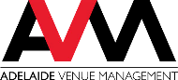

GPO Box 2269, Adelaide South Australia 5001, Australia
avmc.com.au

